

APPLICATION FORM FOR ORGANISATIONS

The Clapham Relief Fund is a local charity which gives grants to those living in conditions of need, hardship or distress who are resident in the Area of Benefit shown on the map overleaf (the local authority wards of Larkhall, Clapham Town, Ferndale, Clapham Common, Brixton Hill, and Thornton). The Trustees have discretion to make grants for items, services or facilities to individuals (generally through their sponsors), and to organisations, which provide such items, services or facilities.

Guidance notes

A. Before completing the form, please make sure that your organisation operates within the Area of Benefit shown on the map attached or in the near vicinity. The trustees will also consider applications from organisations outside of the area who are providing services or facilities to clients or members who are usually resident in the area of benefit.

B. Assistance can only be granted where insufficient funds are available from public sources (e.g. local authority or DWP).

C. Grants are not available to repay debts already incurred.

D. Applications will be considered at meetings of the Trustees, whose decision is final. Meetings are held four times a year – usually early in March, June, September and December. Completed application forms should be submitted two weeks prior to the meeting dates. (By 14th Feb, 14th May, 14th August, and 14th November) In exceptional circumstances, the Chairman and Treasurer can consider applications at other times. Such applications should state clearly the reason for the urgency.

E. All questions on the form must be answered. All information will be treated in the strictest confidence and used solely for the purpose of assessing need. Please note that we require a copy of your organisation’s most recent Annual Report and Accounts.

F. The completed form should be returned to The Clerk to the Trustees, Clapham Relief Fund, PO Box 37978, London, SW4 8WX.

For further information please go to www.claphamrelieffund.org or email enquiries@claphamrelieffund.org.

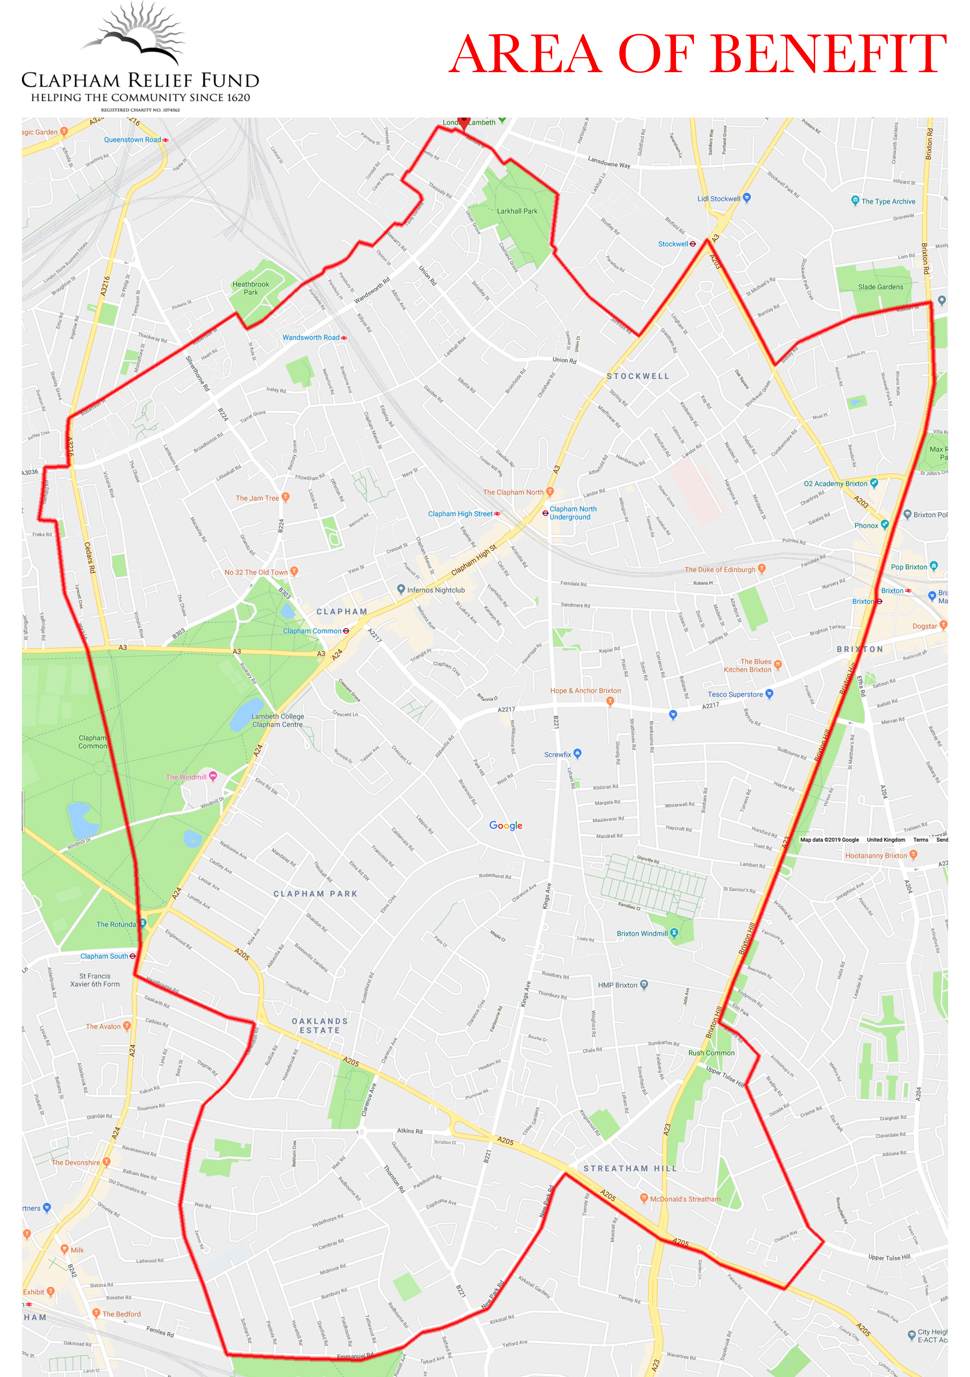

Clapham Relief Fund
Registered Charity Number 1074562

Application for Grant – Organisations
(Please read the guidance notes before completing. All questions must be answered)

Name of organisation___________________________________________________

Address_______________________________________________________________
____________________________________________ Postcode _________________
Contact name_________________________________ Telephone ________________
Position held__________________ email address _____________________________

Nature of activity and/or services offered. (Please enclose a copy of your most recent Annual Report and Accounts.)
__________________________________________________________________________________________________________________________________________________________________________________________________________________

Membership
State the number of residents, clients or participants in your organisation. Please also state the numbers who are currently resident in the area of benefit (see attached map)
________________________________________________________________________________________________________________________________________________________________________________________________________________________________________________________________________________________

Income
State all the sources of income of your organisation, and other organisations to which you have applied for funding for the current project.
_________________________________________________________________________________________________________________________________________________________________________________________________________________

Funding Request
Please give details of the item(s) you need or project you are proposing to run, including an overall budget, and the amount requested from the Clapham Relief Fund
____________________________________________________________________________________________________________________________________________ ______________________________________________________________________________________________________________________________________________________________________________________________________________________________________________________________________________________________________________________________________________________________

Total cost: ___________________________Amount requested: __________________

Cheque payable to: _____________________________________________________
NB: Cheques cannot be made out to individuals

P.T.O.

Where relevant, please state what proportion your members will be contributing to the cost.
____________________________________________________________________________________________________________________________________________
______________________________________________________________________

State any special circumstances in support of your application, including any disability or illness suffered by any of your members.
________________________________________________________________________________________________________________________________________________________________________________________________________________________________________________________________________________________

Declaration on behalf of applicant organisation
I confirm the above details are correct.

Signature of applicant _____________________________ Date ___________________

Name in capitals _________________________________

Position held ___________________________________

Verifier
Please supply the name, address and telephone number of one other person who is not a member of your organisation but who has detailed knowledge of your activities and who can act as a verifier if necessary.

Name_________________________________________________________________

Address______________________________________________________________________________________________________________________________________________________________________________Telephone ____________________

Email address _____________________________

What is your relationship to the applicant organisation? _______________________

