APPLICATION FORM FOR INDIVIDUALS

The Clapham Relief Fund is a local charity which gives grants to those living in conditions of need, hardship or distress who are resident in the Area of Benefit shown on the map overleaf, (the local authority wards of Larkhall, Clapham Town, Ferndale, Clapham Common, Brixton Hill, and Thornton). The Trustees have discretion to make grants to provide items, services or facilities to individuals (generally through their sponsors), and to organisations which provide such items, services or facilities.

Notes for guidance

A. Before completing the form, please make sure that you live within the Area of Benefit shown on the map overleaf. The Trustees will be prepared to consider applications by or on behalf of applicants living in the near vicinity of the Area of Benefit.

B. Assistance will normally only be granted where funding is not available from public sources (e.g. local authority or DWP).

C. Grants will not be made to repay debts already incurred by the applicant.

D. Applications will be considered at meetings of the Trustees, whose decision is final. Meetings are held four times a year – usually in early March, June, September and December. Completed application forms should be submitted at least two weeks prior to the meeting dates. (14th Feb, 14th May, 14th August, 14th November) In exceptional circumstances applications may be considered at other times by the Chairman and Treasurer. Such applications should state clearly the reason for the urgency.

E. All questions on the form must be answered. All information will be treated in the strictest confidence and used solely for the purpose of assessing need.

F. All applications must be verified and countersigned by a sponsor before submission.

G. The completed form should be posted to: Clapham Relief Fund, PO Box 37978, SW4 8WX or emailed to enquiries@claphamrelieffund.org

For further information and/or guidance please go to www.claphamrelieffund.org. or email enquiries@claphamrelieffund.org.

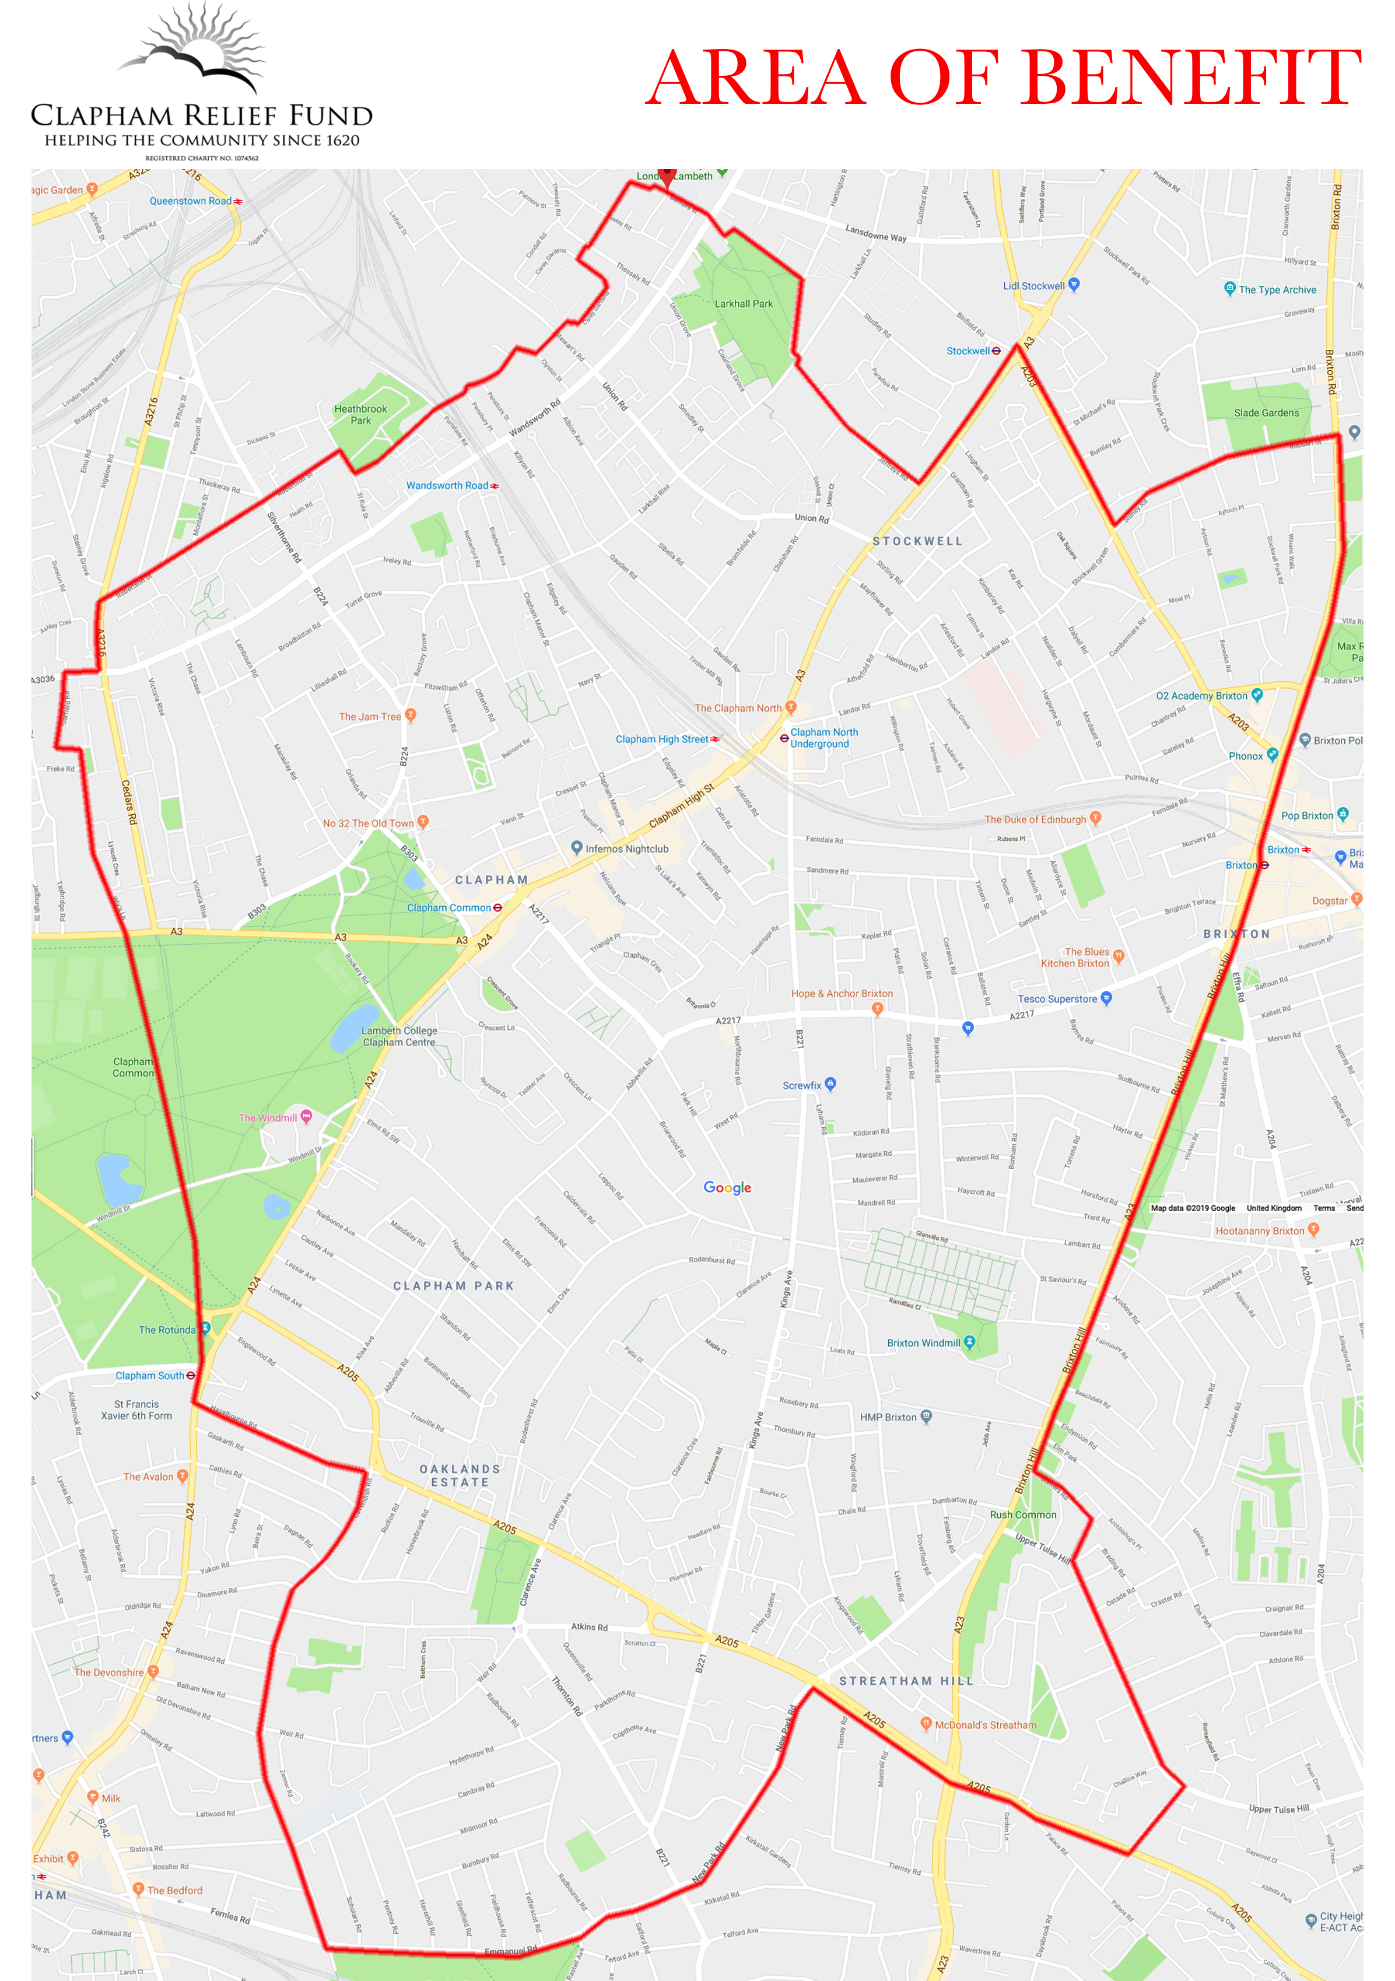

Clapham Relief Fund
Registered Charity Number 1074562

Application for Grant - Individual
(Please read the guidance notes before completing. All questions must be answered)

Surname___________________ First names__________________________________________
Address________________________________________________________________________
____________________________________________ Postcode __________________________
Date of birth __________ Telephone ______________ Email _____________________________

Details of other residents at the address and details of any dependants with ages _____________ ____________________________________________________________________________________________________________________________________________________________

Income
State all sources of income (on a monthly basis)
In the case of husband and wife or partners, the joint income to be shown
Sources | Amount (monthly)
Monthly wage or earnings | £
All pensions, including ill-health/disability/old age etc. | £
Unemployment benefit/universal credit | £
Sickness benefit | £
Income support | £
Housing benefit | £
Any other income, including from savings and/or investments | £
Total | £

Outgoings Amount (monthly)
Rent or Mortgage
Council Tax
Hire purchase and loan repayments (give details)
Other regular outgoings including daily living expenses (give details)
Total | £

If your accommodation is shared, what proportion of the expenses is contributed by person sharing?
_________________________________________________________________________________

Please give details of items (supplier, make, model and price), or services or facilities for which you are requesting a grant and attach estimates or copies of relevant catalogue pages. ___________________________________________________________________________________________________________________________________________________________________________Amount/Cost _____________________________

Sponsor’s bank sort code, account number and reference ___________________________________

NB: BACS payments can only be made to sponsoring organisations. If this is not possible, in exceptional circumstances e-gift cards from the supplier (eg. Argos) may be issued. Receipts must be sent to CRF within two months of the grant being paid.
PTO
Please list any other organisations to which you have applied for a grant

___________________________________________________________________________

State any special circumstances in support of your application including any disability or illness

_______________________________________________________________________________________________________________________________________________________________________________________

Declaration

I confirm that the above details are correct and that I am currently resident in the area, or near vicinity defined on the attached map. I agree that any grant made will be spent only on the items specified, that itemised receipts will be sent to the Clerk within two months of the date of receipt of the grant and that any unspent amount will be returned. I undertake to inform you if my current needs are met by any other organisation to which I may have applied, or if my circumstances change.

I understand that you may contact my sponsor and, where applicable, other charities I have mentioned because this can help with assessing my application. I also understand that my details will only be used to assess my application, will be stored electronically to fulfil the charity’s audit obligations and that this application form and associated documents will be stored securely and destroyed in line with General Data Protection Regulations.

Signature of applicant ____________________________________ Date ___________________

DECLARATION BY SPONSOR (to be completed by a Social Worker, Minister of Religion, GP, Teacher, Trustee of the Clapham Relief Fund, or someone of similar standing who is known to the applicant)

I confirm that the applicant is known to me, that he/she lives within the Area of Benefit shown on the map or the near vicinity and that, to the best of my knowledge, the information given in this form is correct.

Signature _____________________________________ Date _____________________________

Name (capitals) ________________________________ Profession/vocation _________________

Address ________________________________________________________________________

Telephone __________________________ Email address ________________________________

Any additional relevant information from sponsor in support of application

______________________________________________________________________________

______________________________________________________________________________

______________________________________________________________________________

